Task on IAM
1.Create one IAM user and assign EC2 and S3 full access roles.
Steps:
1)Login to AWS Console
2)Search for IAM Service, IAM is used to manage users, groups, and permissions.
3)Create new user named Naseer.
4)Enable console access This allows user to login to AWS dashboard.
5)Attach policies AmazonEC2FullAccess and AmazonS3FullAccess, Policies define permissions.
AmazonEC2FullAccess → full control over EC2
AmazonS3FullAccess → full control over S3

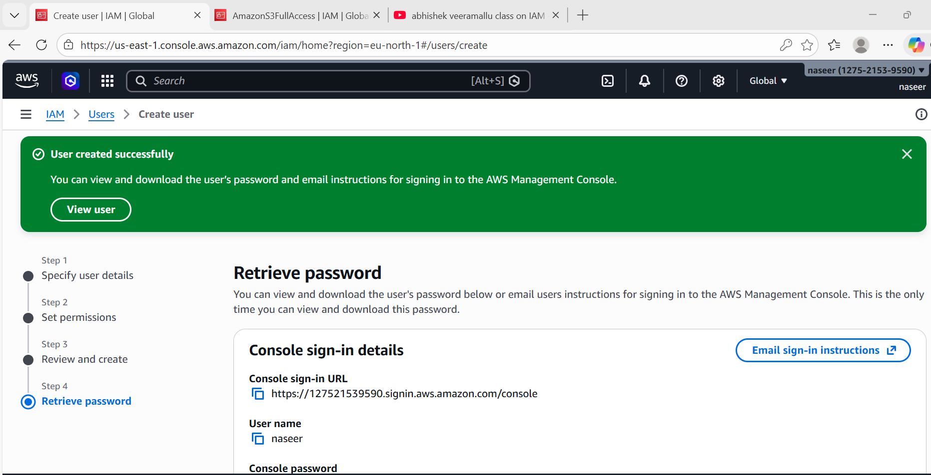
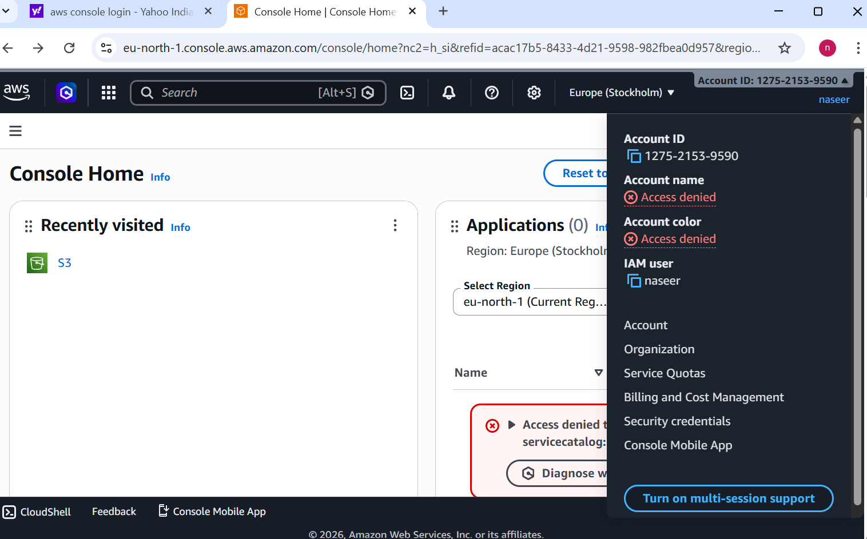
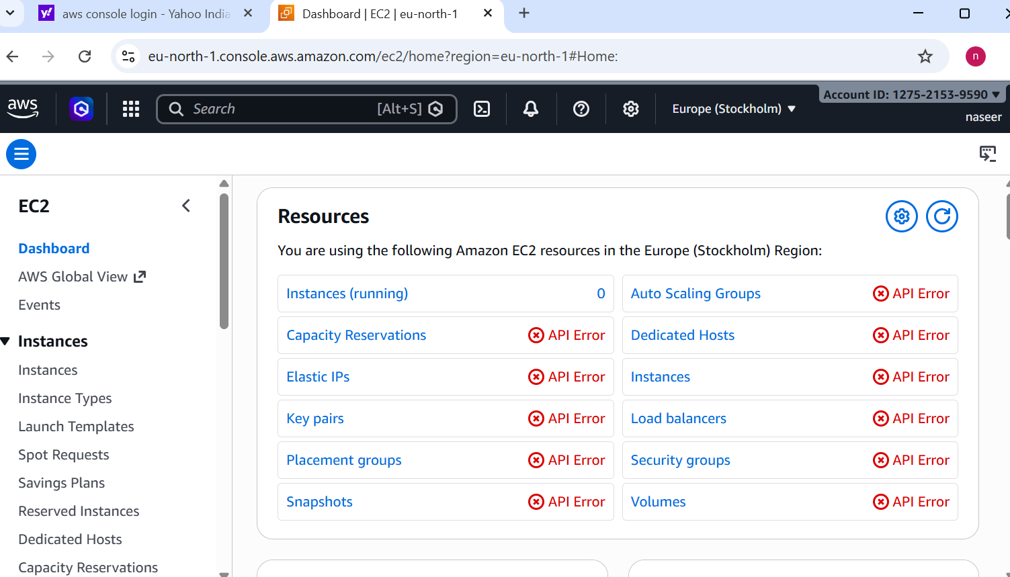
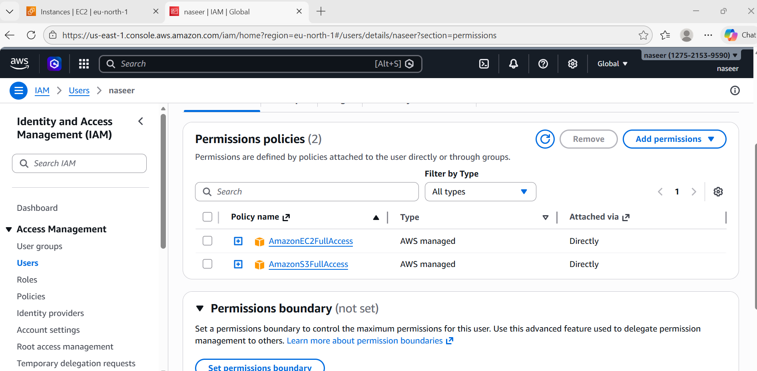
2. Create one group in IAM and assign read access for EC2.
Steps:
1) Create group EC2-Read-Group, Group is used to manage multiple users with same permissions.
2)Attach policy Amazon EC2ReadOnlyAccess, This allows viewing EC2 but not modifying.

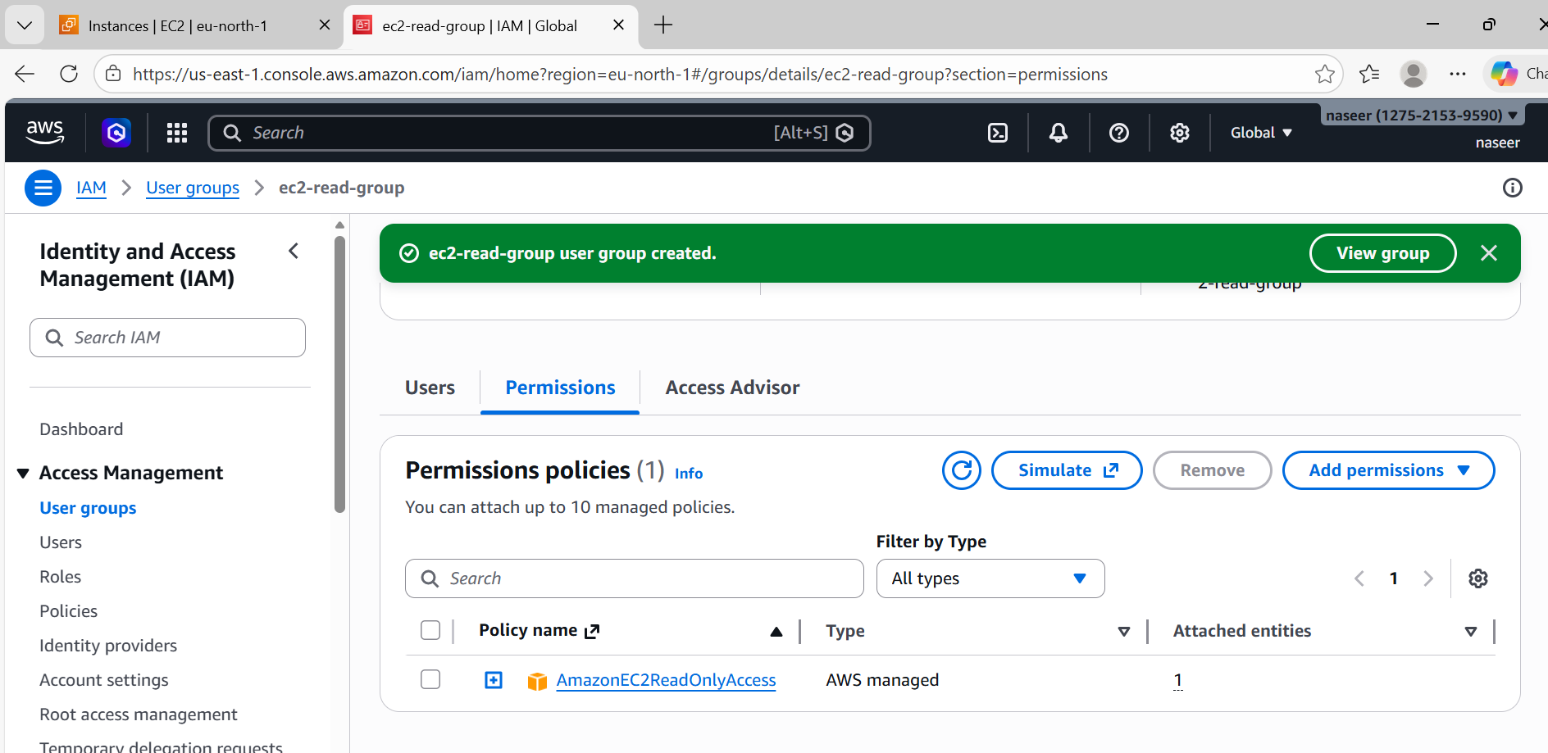

3. Create a new user named "Devops" and add to the group created in task 2.
Steps:
1) Create user Devops.
2)Add user to EC2-Read-Group
3)User inherits permissions from group automatically.

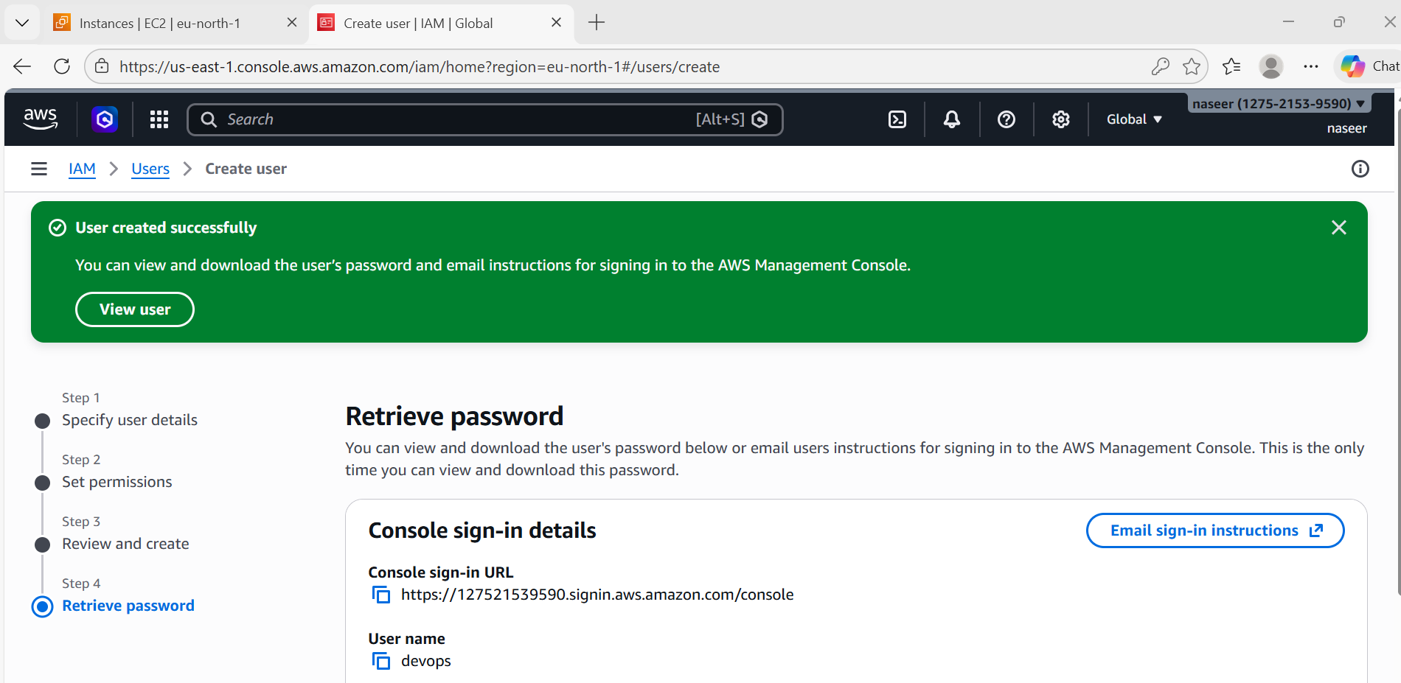
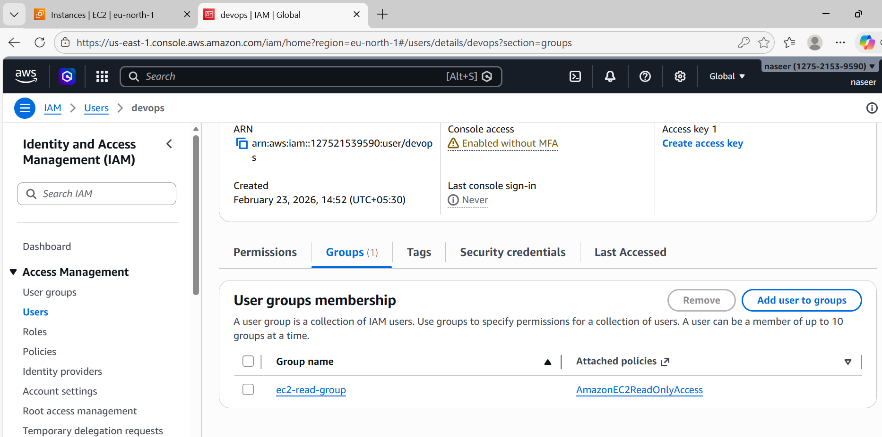

4. Write a bash script to create an IAM user with VPC full access.
Steps:
1) Create bash script file
2) Use aws iam create-user command, Creates IAM user automatically.
3) Attach AmazonVPCFullAccess policy, Provides full access to VPC service.
4)Run script, Script executes commands automatically.

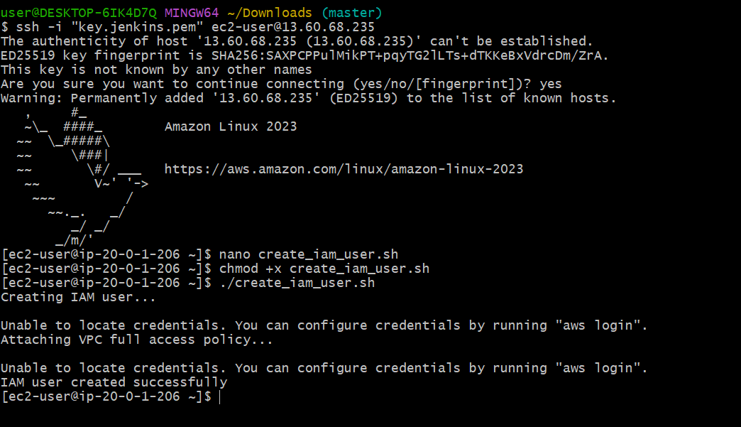

5. Create an IAM policy to allow EC2 access for a specific user in specific regions only.
Steps:
1) Create new policy using JSON, JSON defines permissions.
2) Restrict region using condition.
3) Attach policy to user, User now can access EC2 only in allowed region.

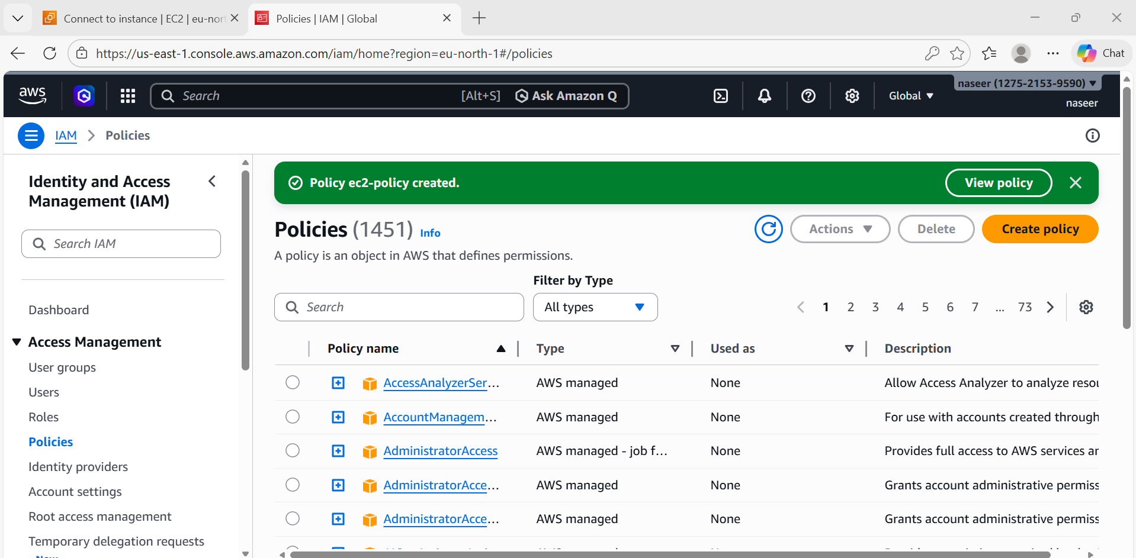
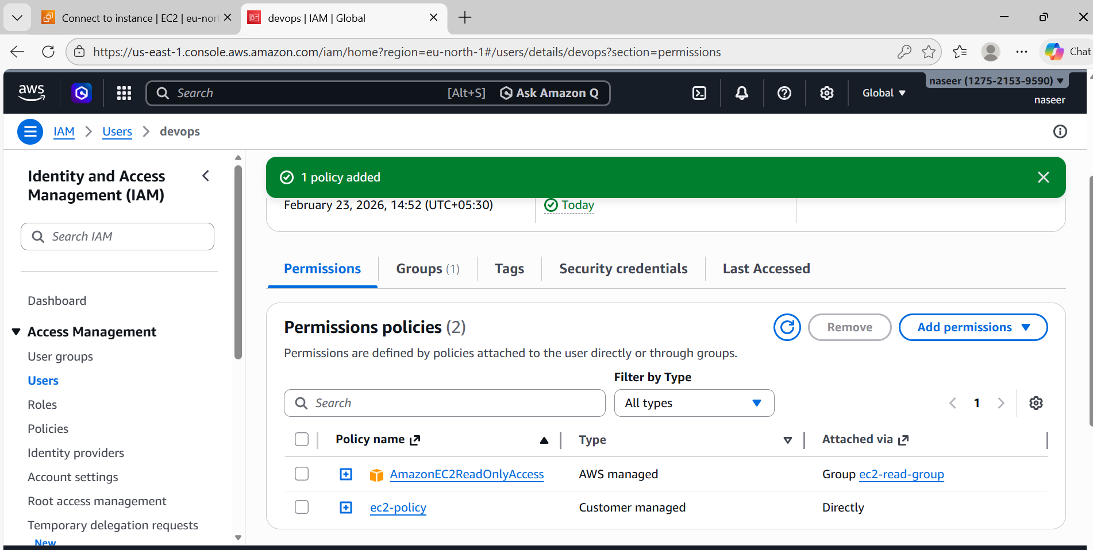
6. We have two accounts: Account A and Account B. Account A user should access an S3 bucket in Account B.
(Collaborate with a team member and execute this. This is mostly asked in every interview.)
1. Overview
Cross-account role assumption allows one AWS account (Source Account) to access resources in another AWS account (Target Account) securely using IAM roles and temporary credentials.
Example:
Source Account ID: 127521539590
Target Account ID: 708035287026
Role Name: friend-s3-access
Purpose:
This is used when you want to give secure access between different AWS accounts without sharing permanent credentials.
2. Key Components
Source Account:
The account that wants access.
Target Account:
The account that owns the resources.
IAM Role:
Created in Target Account. This role contains permissions (example: S3 access).
Trust Policy:
Defines WHO can assume the role.
Permission Policy:
Defines WHAT actions are allowed.
STS (Security Token Service):
Generates temporary credentials.
Step 1:
1) Create Role in Target Account
2) Go to AWS Console → IAM → Roles → Create Role
3) Select Trusted Entity Type → AWS Account
4) Enter Source Account ID: 127521539590
5) Attach permissions: AmazonS3FullAccess
6) Role Name friend-s3-access and Click Create Role
Step 2:
1) Configure Trust Policy
2) Go to IAM → Roles → friend-s3-access → Trust Relationships → Edit
Add:
{
"Version": "2012-10-17",
"Statement": [
{
"Effect": "Allow",
"Principal": {
"AWS": "arn:aws:iam::127521539590:root"
},
"Action": "sts:AssumeRole"
}
]
}
This allows Source Account to assume the role.
Step 3:
1) Add Permission in Source Account
2) Go to IAM → Users → Select user → Add Inline Policy
Add:
{
"Version": "2012-10-17",
"Statement": [
{
"Effect": "Allow",
"Action": "sts:AssumeRole",
"Resource": "arn:aws:iam::708035287026:role/friend-s3-access"
}
]
}
This allows user to assume the target role.
Step 4:
- Assume Role using AWS CLI
Command:
aws sts assume-role \
--role-arn arn:aws:iam::708035287026:role/friend-s3-access \
--role-session-name test
This generates temporary credentials.

Step 5: Export Temporary Credentials
export AWS_ACCESS_KEY_ID=XXXX
export AWS_SECRET_ACCESS_KEY=XXXX
export AWS_SESSION_TOKEN=XXXX
Step 6:
Verify Access
command:
aws sts get-caller-identity
Output should show Target Account ID.
